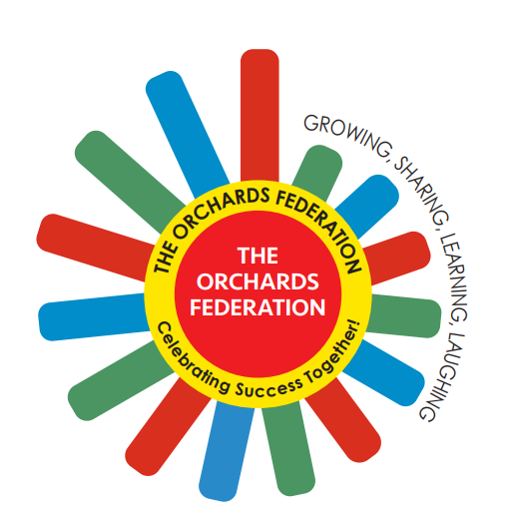

THE ORCHARDS FEDERATION

Accessibility Plan
2025-2028

Aims

Schools are required under the Equality Act 2010 to have an accessibility plan. The purpose of the plan is to:
  - Increase the extent to which disabled pupils can participate in the curriculum
  - Improve the physical environment of the schools to enable disabled pupilsto take better advantage of education, benefits, facilities and services provided
  - Improve the availability of accessible information to disabled pupils
Our schools aim to treat all pupils fairly and with respect. This involves providing access and opportunities for all pupils without discrimination of any kind. We are committed to providing an environment that enables full access to the curriculum, facilities and information that values and includes all pupils, staff, parents and visitors regardless of their education, physical, sensory, social, spiritual, emotional and cultural needs. We are committed to taking positive action in the spirit of the Equality Act 2010 with regard to disability and to reinforcing our culture of inclusion, support and awareness within the schools.
Our Federation is also committed to ensuring staff are trained in equality issues with reference to the Equality Act 2010, including understanding disability issues.

If you have any concerns relating to accessibility in the Federation, the complaints procedure sets out the process for raising these concerns.
We have included a range of stakeholders in the development of this accessibility plan, including pupils, parents, staff and governors of the schools.

The test of whether an impairment affects normal day-to-day activity is whether it affects one or more of the following:

- Mobility;
- Manual dexterity;
- Physical co-ordination;
- Continence;
- Ability to lift, carry or otherwise move everyday objects;
- Speech, hearing or eyesight;
- Memory or ability to concentrate, learn or understand;
- Perception of risk of physical danger.

The Accessibility Plan will be reported upon annually at a Meeting of the Federation Governing Board in respect of progress and outcomes, and provide a projected plan for the three year period ahead of the next review date. This plan reflects new statutory requirements for the setting of Equality Objectives.

The Accessibility Plan is structured to complement and support the Federation’s Equality Opportunities Policy and will similarly be published on the Federation website. We are committed to providing an environment that enables full access to the curriculum, facilities and information that values and includes all pupils, staff, parents and visitors regardless of their education, physical, sensory, social, spiritual, emotional and cultural needs. We are committed to taking positive action in the spirit of the Equality Act 2010 with regard to disability and to reinforcing our culture of inclusion, support and awareness within the Federation.

The Orchards Federation Accessibility Plan shows how access is to be improved for pupils with disabilities, staff and visitors to the schools in a given timeframe and anticipating the need to make reasonable adjustments to accommodate their needs where practicable. The Accessibility Plan will contain relevant and timely actions to enable all stakeholders to access: the curriculum, the physical environment, and information.

Legislation and guidance

This document meets the requirements of schedule 10 of the Equality Act 2010 and the Department for Education (DfE) guidance for schools on the Equality Act 2010.
The Equality Act 2010 defines an individual as disabled if he or she has a physical or mental impairment that has a ‘substantial’ and ‘long-term’ adverse effect on his or her ability to undertake normal day to day activities.
Under the Special Educational Needs and Disability (SEND) Code of Practice, ‘long- term’ is defined as ‘a year or more’ and ‘substantial’ is defined as ‘more than minor or trivial’. The definition includes sensory impairments such as those affecting sight or hearing, and long-term health conditions such as asthma, diabetes, epilepsy and cancer.
Schools are required to make ‘reasonable adjustments’ for pupils with disabilities under the Equality Act 2010, to alleviate any substantial disadvantage that a disabled
pupil faces in comparison with non-disabled pupils. This can include, for example, the provision of an auxiliary aid or adjustments to premises.
This document will be reviewed every 3 years, but may be reviewed and updated more frequently if necessary. It will be approved by the Governing Body annually.

Links with other policies

This accessibility plan is linked to the following policies and documents:
  - Risk assessment policy
  - Health and safety policy
  - Equality Policy
  - Special educational needs (SEN) information report
  - Supporting pupils with medical conditions policy
  - Curriculum policy
  - Equality Objectives
  - Single Equality Policy
  - Health and Safety Policy
  - Special Educational Needs Policy
  - Behaviour Management Policy
  - School Development plan

Action Plan

This action plan sets out the aims of our accessibility plan in accordance with the Equality Act 2010.
- Access to the Curriculum

Objective | Actions | Timescale | Responsibility | Success Criteria
Ensure teaching continues to be differentiated and personalised | Provide ongoing staff CPD on adaptive teaching, sensory-friendly approaches, and assistive technology use | Ongoing (termly) | Headteacher, staff leads in relevant areas | All pupils can engage with learning at their level
Further enhance communication access | Extend use of communication aids (eg digitally assisted AAC such as apps on the smart boards and class tablets)  Use visual timetables across classrooms. Use Widget consistently across the Federation.  Ensure all classrooms have appropriate surfaces to display widgets eg symbol for drink on drink storage cupboard | July 2026  January 2026  April 2026 | SALT team, communication leads, class teachers | Pupils can express choices and needs effectively
Continue to increase access to enrichment activities | Review after-school clubs, trips, and visitors to ensure accessibility for all pupils | Annual review | Executive Head Teacher  Head Teachers  Education visits coordinators | All pupils participate in wider Federation life

- Physical Environment

Objective | Actions | Timescale | Responsibility | Success Criteria
Maintain safe, accessible school site at all buildings | Carry out annual accessibility audit; ensure corridors, classrooms, and outdoor areas remain free from barriers | Annual | Premises Manager
  All areas are accessible to pupils and other stakeholders with mobility needs
Improve outdoor learning access | Develop memorial garden to be fully wheelchair accessible  Increase forest school access for all children | December 2026 | Site team  Head Teachers | Outdoor areas fully inclusive and stimulating
Continue to enhance specialist facilities | Review need for additional sensory spaces and therapy equipment.  Continue with annual programme to add new spaces | August 2027 | Executive Head Teacher  Head Teachers | Pupils’ physical and sensory needs supported effectively

- Information Access

Objective | Actions | Timescale | Responsibility | Success Criteria
Improve accessible communication with parents | Provide information in alternative formats (large print, symbols, easy-read, translated versions) | Ongoing | Admin Team, Head Teachers | Parents and carers receive information in their preferred format
Support pupil understanding of school information | Use symbol-supported materials, social stories, and visual signage throughout school | September 2026 | Class Teachers | Pupils can navigate routines and expectations independently
Strengthen digital access | Ensure website is accessible (screen-reader friendly, plain English, high contrast) | July 2027 | Operations Manager, Admin Team | Families and stakeholders can access key information online

