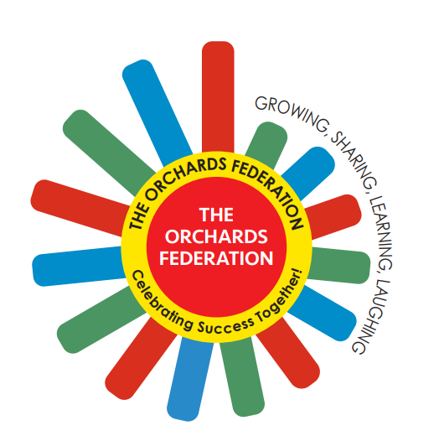

THE ORCHARDS FEDERATION

Equality Policy

Aims

Our school aims to meet its obligations under the Public Sector Equality Duty (PSED) by having due regard to the need to:
- Eliminate discrimination, harassment, victimisation and other conduct that is prohibited by the Equality Act 2010
- Advance equality of opportunity between people who share a protected characteristic and people who do not share a relevant protected characteristic
- Foster good relations across all characteristics – between people who share a protected characteristic and people who do not share it. The protected characteristics are:
- Age
- Disability
- Gender reassignment
- Marriage or civil partnership
- Pregnancy and maternity
- Race
- Religion or belief
- Sex
- Sexual orientation

Our school aims to promote respect for difference and diversity in accordance with our values:
BELONGING, RESPONSIBILITY, RESPECT, INTEGRITY AND COMPASSION

Legislation and guidance

This document meets the requirements under the following legislation:
- The Equality Act 2010, which introduced the Public Sector Equality Duty and protects people from discrimination
- The Equality Act 2010 (Specific Duties) Regulations 2011, which require schools to publish information to demonstrate how they are complying with the Public Sector Equality Duty and to publish equality objectives
This document is also based on Department for Education (DfE) guidance: The Equality Act 2010 and schools, the technical guidance for schools from the Equality and Human Rights Commission and guidance from the Government Equalities Office on meeting the specific duties that support the Public Sector Equality Duty.

Roles and Responsibilities

The governing board will:
- Ensure that the equality information and objectives as set out in this statement are published and communicated throughout the school, including to staff, pupils and parents/carers
- Ensure that the published equality information is updated at least every year, and that the objectives are reviewed and updated at least every 4 years
- Delegate responsibility for monitoring the achievement of the objectives on a daily basis to the Executive Head Teacher and Head Teachers
- Support the Executive Head Teacher and Head Teachers in identifying any staff training needs, and arrange for delivery of training as necessary
All school staff are expected to have regard to this document and to work to achieve the objectives

Eliminating discrimination

The Federation is aware of its obligations under the Equality Act 2010 and complies with non-discrimination provisions.
Where relevant, our policies include reference to the importance of avoiding discrimination and other prohibited conduct.
Staff and governors are regularly reminded of their responsibilities under the Equality Act – for example, during meetings.

Advancing equality of opportunity

As set out in the DfE guidance on the Equality Act, the school aims to advance equality of opportunity by:
- Removing or minimising disadvantages suffered by people that are connected to a particular characteristic they have (e.g. pupils with disabilities)
- Taking steps to meet the particular needs of people who have a particular characteristic
- Encouraging people who have a particular characteristic to participate fully in any activities (e.g. encouraging all pupils to be involved in the full range of school societies)
In fulfilling this aspect of the duty, the school will:
- Publish attainment data each academic year showing how pupils with different characteristics are performing
- Analyse the data referenced above to determine strengths and areas for improvement, implement actions in response and publish this information
- Make evidence available identifying improvements for specific groups (e.g. declines in incidents of racism)
- Publish further data about any issues associated with particular protected characteristics, identifying any issues which could affect our own pupils

Fostering good relations

The Federation aims to foster good relations between those who share a protected characteristic and those who do not share it by:
- Promoting tolerance, friendship and understanding of a range of religions and cultures through different aspects of our curriculum. This includes teaching in RE, citizenship and personal, social, health and economic (PSHE) education, but also activities in other curriculum areas. For example, as part of teaching and learning in English/reading, pupils will be introduced to literature from a range of cultures
- Making pupils aware of our behaviour and anti-bullying policies
- Holding assemblies dealing with relevant issues. Pupils will be encouraged to take a lead in such assemblies, and we will also invite external speakers to contribute
- Working with our local community. This includes organising school trips and activities based around the local community
- We have developed links with people and groups who have specialist knowledge about particular characteristics, which helps inform and develop our approach

Equality considerations in decision making

The school ensures it has due regard to equality considerations whenever significant decisions are made. We consider equality implications before and at the time that we develop policy and make decisions and continue to review these on a continuing basis.
The school always considers the impact of significant decisions on particular groups. For example, when a school trip or activity is being planned, the school considers whether the trip:
- Cuts across any religious holidays
- Is accessible to pupils with disabilities
- Has equivalent facilities for boys and girls

Equality objectives

Objective 1
To further promote equality, diversity and inclusion actions across our staff body.

Objective 2
To use performance data to monitor pupil achievement and respond to variations between groups of learners.

Monitoring

School-specific equality objectives will be reviewed by the governing board at least every 4 years.
This document will be reviewed by the governing board annually, to ensure continued compliance with the PSED.

Links with other policies

This policy is linked to the following policies and documents:
- Accessibility plan
- SEN information report
- SEND policy

